Acids and Bases

* An acid-base reaction will proceed when the acid and base react to form conjugate products that are **weaker** than the reactants
* Lewis acids (electron acceptors) and Lewis bases (electron donors)
* Bronsted-Lowry acids (proton donors) and Bronsted-Lowry bases (proton acceptors)
* Amphoteric molecules can act either as acids or bases e.g. water
* Acid dissociation constant Ka
  + Stronger acid → higher Ka (dissociates more into H+ and A-) → lower pKa
  + Acidity increases with electronegativity (across the periodic table) and with size (down the periodic table)

Nucleophiles

* “Nucleus-loving”, and contain lone pairs or π bonds
* Have increased electron density and often carry a negative charge
* Nucleophilicity is similar to basicity
  + Nucleophilicity is a kinetic property
  + Basicity is a thermodynamic property
* Four factors
  + Charge → nucleophilicity increases with increasing electron density
  + Electronegativity → nucleophilicity decreases as electronegativity increases because these atoms are less likely to share electron density
  + Steric hindrance → Bulkier molecules are less nucleophilic
  + Solvent → Protic solvents can hinder nucleophilicity by protonating the nucleophile or through hydrogen bonding
    - Protic solvents (can HB) → I- > Br- > Cl- > F-
    - Aprotic solvents (cannot HB) → F- > Cl- > Br- > I-

Electrophile

* “Electron-loving” and contain a positive charge or are positively polarized

Leaving groups

* Molecular fragments that retain the electrons after heterolysis (a bond is broken and both electrons are given to one of the two products)
* Leaving group ability can be augmented by:
  + Resonance
  + Inductive effects from electron-withdrawing groups
* Weak conjugate bases of strong acids (like I-, Br-, Cl-) make good leaving groups
* E.g. Br- is the conjugate base of HBr; HO- is the conjugate base of water
  + HBr is a much stronger acid than water → so Br- is a better leaving group than HO- → Br- is also more stable in solution

Nucleophilic Substitution Reactions

1. SN1 (**unimolecular**) proceed in **two steps**
   1. In the first step, the leaving group leaves, forming a carbocation
   2. In the second step, the nucleophile attacks the planar carbocation from **either side**, leading to a **racemic** mixture of products
   3. SN1 reactions prefer more substituted carbons because the alkyl groups can donate electron density and **stabilize the positive charge** of the carbocation
   4. The rate is dependent only on the concentration of the substrate: rate = k[R-L] where R-L is an alkyl group containing a leaving group
2. SN2 (**bimolecular**) proceed in **one concerted step**
   1. The nucleophile attacks at the same time as the leaving group leaves
   2. The nucleophile must perform a **backside attack**, which leads to an inversion of stereochemistry
      1. The absolute configuration is changed - (R) to (S) and vice versa IF the incoming nucleophile and the leaving group have the same priority in the molecule
   3. SN2 reactions prefer less substituted carbons because the alkyl groups cause **steric hindrance and inhibit the nucleophile** from accessing the electrophilic substrate carbon
   4. The rate is dependent on the concentrations of both the substrates and the nucleophile: rate = k[Nu:][R-L]

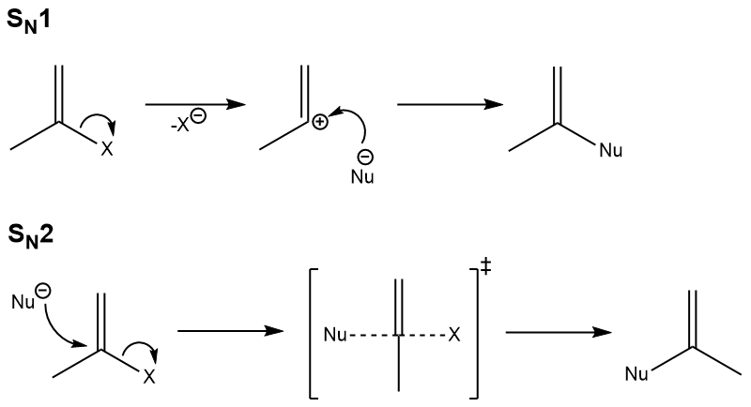

Oxidation Reactions

* Primary alcohols can be oxidized to:
  + Aldehydes by PCC (weak OA)
  + Carboxylic acids by CrO3, Na2Cr2O7, K2Cr2O7 (strong OA)
* Secondary alcohols can be oxidized to:
  + Ketones by most oxidizing agents e.g. PCC
* Aldehydes can be oxidized to:
  + Carboxylic acids by most oxidizing agents e.g. H2Cr2O7, KMnO4

Reduction Reactions

* LiAlH4 (strong RA) can reduce:
  + Aldehydes/ ketones/ carboxylic acids → alcohols
  + Amides → amines
  + Esters → a pair of alcohols

Chemoselectivity

* Diols are often used as protecting groups for aldehyde or ketone carbonyls
* Alcohols may be protected by conversion to *tert*-butyl ethers

Reactivity of carboxylic acid derivatives

* Anhydrides > carboxylic acids and esters > amides (from highest to lowest)
* Derivatives of higher reactivity can form derivatives of lower reactivity but not vice versa